NARROGIN SENIOR HIGH SCHOOL
Department of Crime Investigation
COLD CASE DIVISION

Dear Detective,
The Narrogin Senior High School Department of Crime Investigation would like to thank you for offering to present a report on a current cold case.
You have all been hand-picked by the Department due to your renowned investigative skills and expertise.
We are sure that your fresh, young eyes and enquiring minds are just what is needed to assist us with our investigation.
You are required to prepare an independent and impartial report on a current cold case. Your report needs to investigate the discovery of the deceased person’s body and all the evidence.
You will need to present a report of your findings. You will also need to submit three theories regarding how the person came to be deceased. You must rank and rate these theories according to how probable you believe them to be based on the evidence you have collected.
You are welcome to present a maximum of one new theory of your own, and in fact are encouraged to do so. However, your new theory must be based on the evidence you have collected and on scientific fact.
Good luck, the Department looks forward to receiving your reports.

Miss Rebecca Donavon
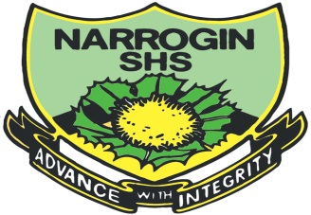
Chief Forensic Investigator
Department of Crime Investigation
Narrogin Senior High School

